***Use Cases and Results:***

***Use Case 1:***

*Create an API where you can submit a purchase for a ticket. Details included in the receipt are:*

*a) From, To, User , price paid.*

*(i) User should include first and last name, email address*

*The user is allocated a seat in the train. Assume the train has only 2 sections, section A and section B.*

***a. Create an user:***

*Method: Post*

*http://localhost:8080/trainusers/1*

*{*

*"user_id": 1,*

*"first_name": "Andre",*

*"last_name": "Agassi",*

*"email": "andreagassi@gmail.com"*

*}*

*or*

*{*

*"first_name": "Andre",*

*"last_name": "Agassi",*

*"email": "andreagassi@gmail.com"*

*}*

*http://localhost:8080/trainusers/2*

*{*

*"user_id": 2,*

*"first_name": "Boris",*

*"last_name": "Becker",*

*"email": "boris@gmail.com"*

*}*

*{*

*"first_name": "Boris",*

*"last_name": "Becker",*

*"email": "boris@gmail.com"*

*}*

*http://localhost:8080/trainusers/4*

*{*

*"user_id": 4,*

*"first_name": "Steffi",*

*"last_name": "Graf",*

*"email": "steffi@gmail.com"*

*}*

*{*

*"first_name": "Steffi",*

*"last_name": "Graf",*

*"email": "steffi@gmail.com"*

*}*

*\*) Create this one for delete and dont reserve tickets for this:*

*http://localhost:8080/trainusers/3*

*{*

*"user_id": 3,*

*"first_name": "Gabrieala",*

*"last_name": "Sabatini",*

*"email": "Gabrieala@gmail.com"*

*}*

*{*

*"first_name": "Gabrieala",*

*"last_name": "Sabatini",*

*"email": "Gabrieala@gmail.com"*

*}*

**Input through API Client: Talend API Client**

*Eg:*

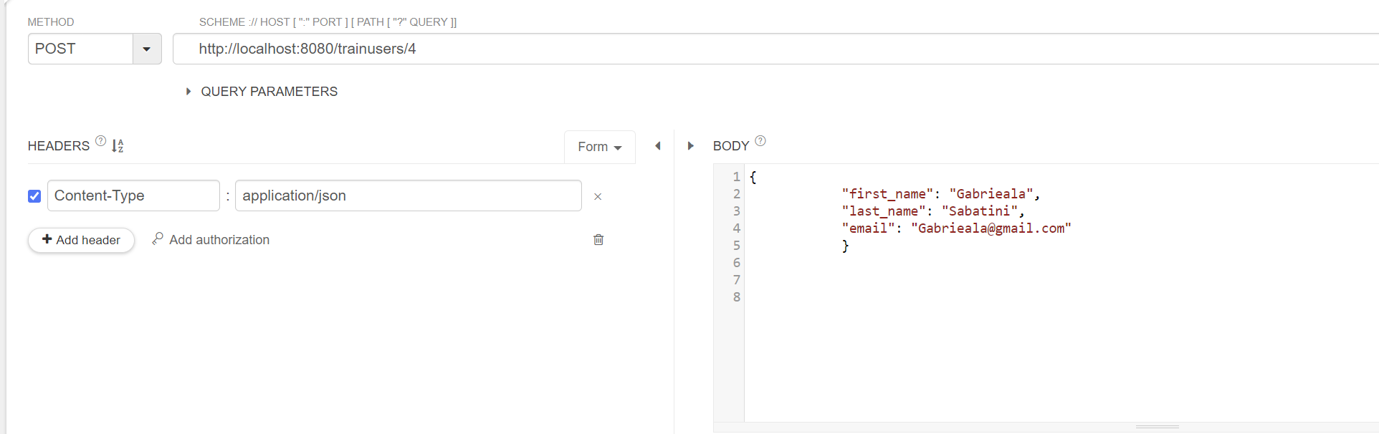

***In Memory DB Output for Users:***

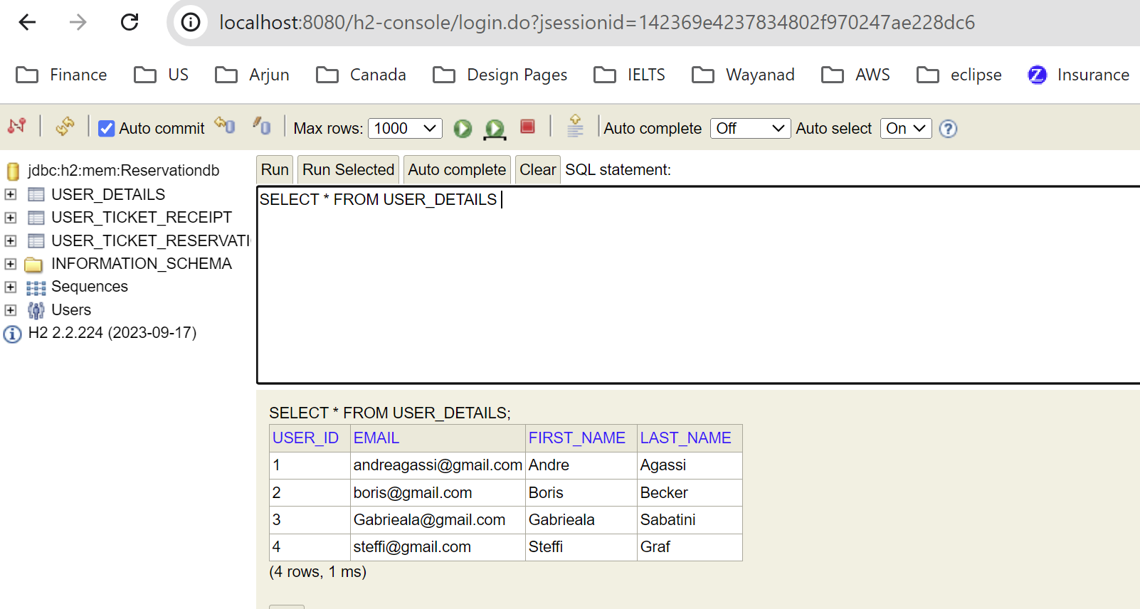

***API Call Output for Users:***

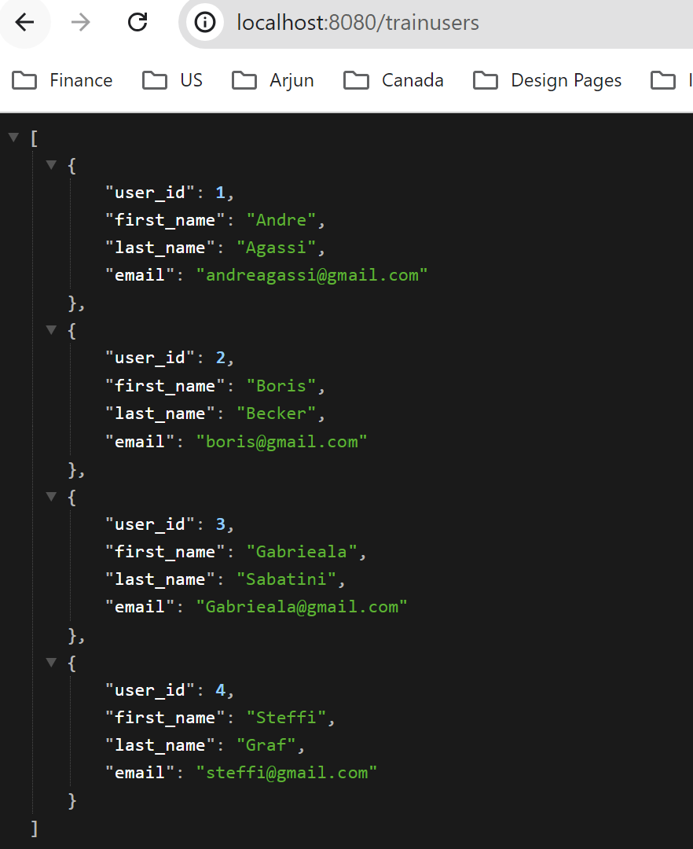

*\*\*\*\*\*\*\*\*\*\*\*\*\*\*\*\*\*\*\*\*\*\*\*\*\*\*\*\*\*\*\*\*\*\*\*\*\*\*\*\*\*\*\*\*\*\*\*\*\*\*\*\*\*\*\*\*\*\*\*\*\*\*\*\*\*\*\*\*\*\*\*\*\*\*\*\*\**

***b. Submit a ticket by user:***

*Method: Post*

*i) http://localhost:8080/trainusers/1/reserve*

*ii) http://localhost:8080/trainusers/2/reserve*

*iii) http://localhost:8080/trainusers/4/reserve*

*will reserve/allocate a seat either in section A or B in the train.Ticket,Receipt will be given.*

*In Receipt, we will have default from, to, price paid.*

**Input through API Client: Talend API Client**

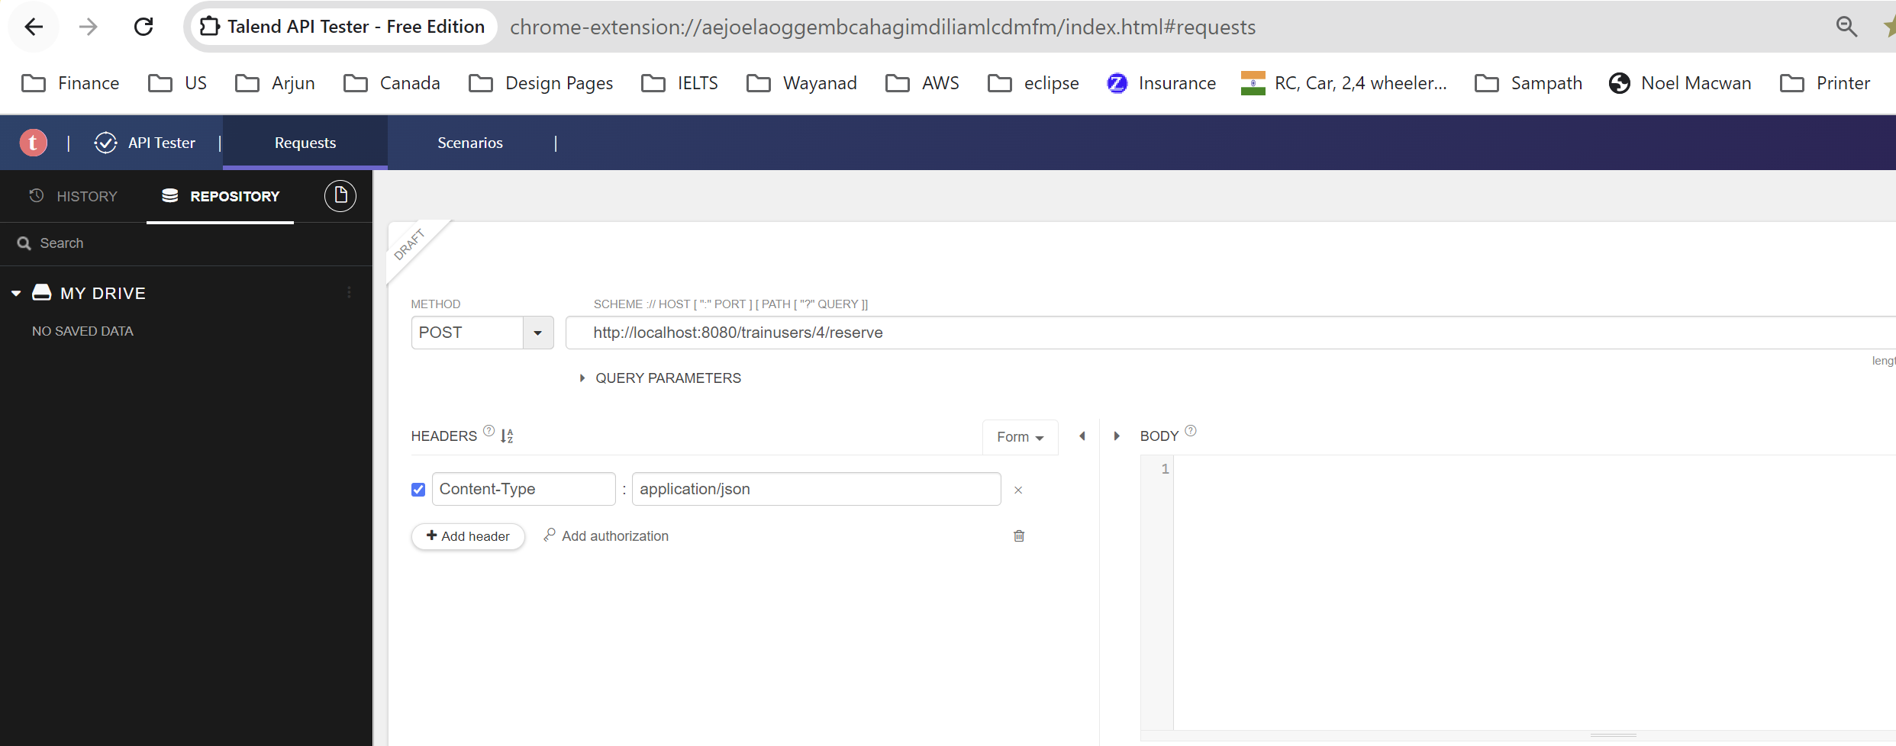

***Output in DB:***

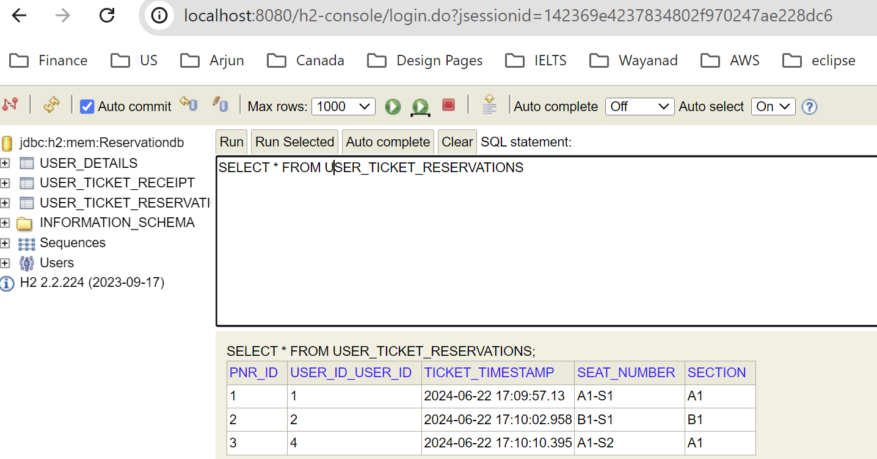

***API Call Output for Reservations:***

***All the users Reservations:***

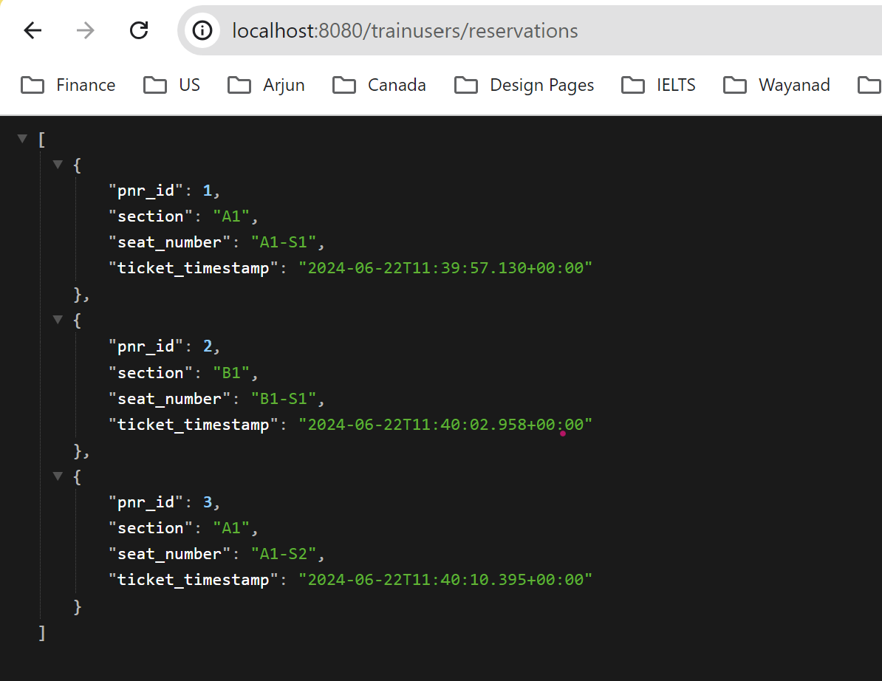

***For a single user Reservation:***

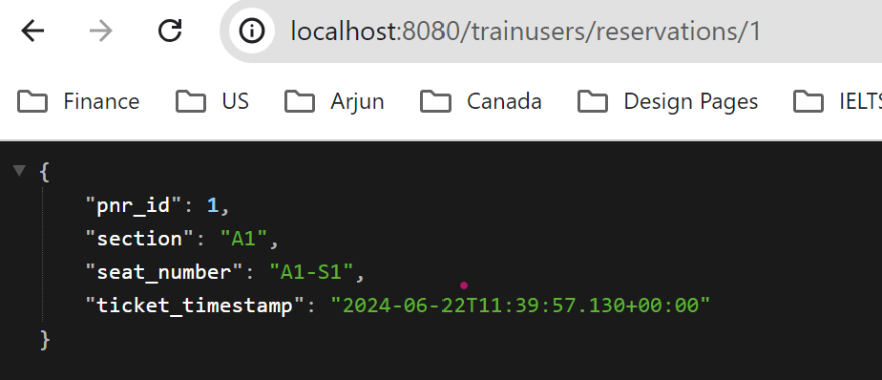

*\*\*\*\*\*\*\*\*\*\*\*\*\*\*\*\*\*\*\*\*\*\*\*\*\*\*\*\*\*\*\*\*\*\*\*\*\*\*\*\*\*\*\*\*\*\*\*\*\*\*\*\*\*\*\*\*\*\*\*\*\*\*\*\*\*\*\*\*\*\*\*\*\*\*\*\*\*\*\*\*\*\*\*\**

*2) An API that shows the details of the receipt for the user:*

*For single user:*

1. [*http://localhost:8080/trainusers/receipts/1*](http://localhost:8080/trainusers/receipts/1)

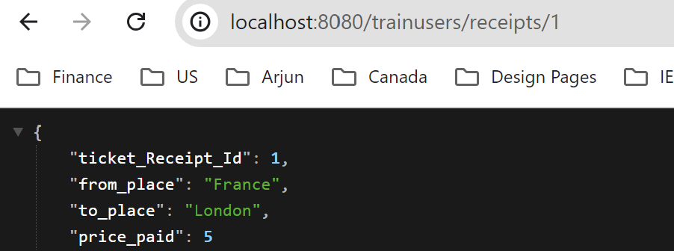

*b. http://localhost:8080/trainusers/receipts/2*

*c. http://localhost:8080/trainusers/receipts/3*

*For all users receipts:*

1. [*http://localhost:8080/trainusers/receipts*](http://localhost:8080/trainusers/receipts)

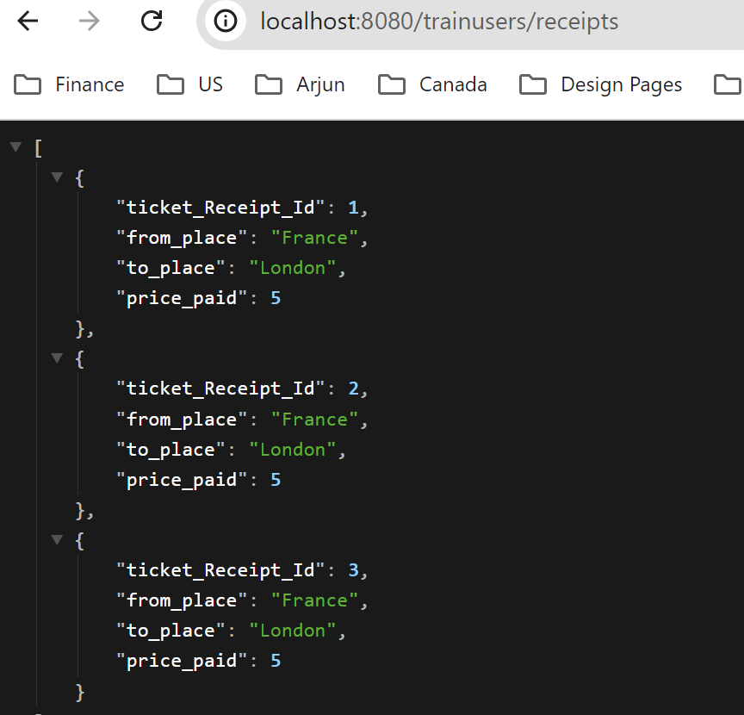

***DB Output:***

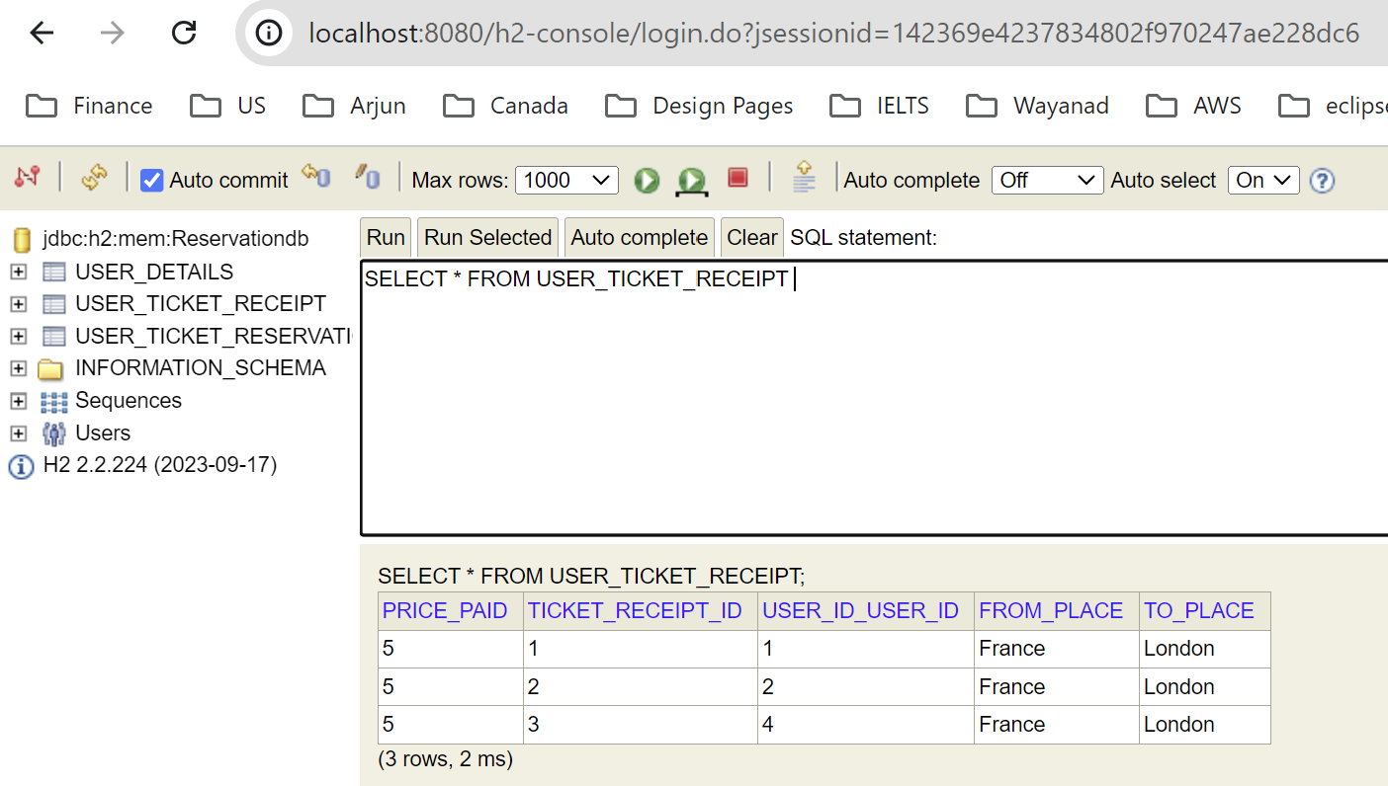

*\*\*\*\*\*\*\*\*\*\*\*\*\*\*\*\*\*\*\*\*\*\*\*\*\*\*\*\*\*\*\*\*\*\*\*\*\*\*\*\*\*\*\*\*\*\*\*\*\*\*\*\*\*\*\*\*\*\*\*\*\*\*\*\*\*\*\*\*\*\*\*\*\*\*\*\*\*\*\*\*\*\*\*\*\*\*\**

*3) An API that lets you view the users and seat they are allocated by the requested section:*

*Retrieval by section:*

1. [*http://localhost:8080/trainusers/sectionreservations/A1*](http://localhost:8080/trainusers/sectionreservations/A1)

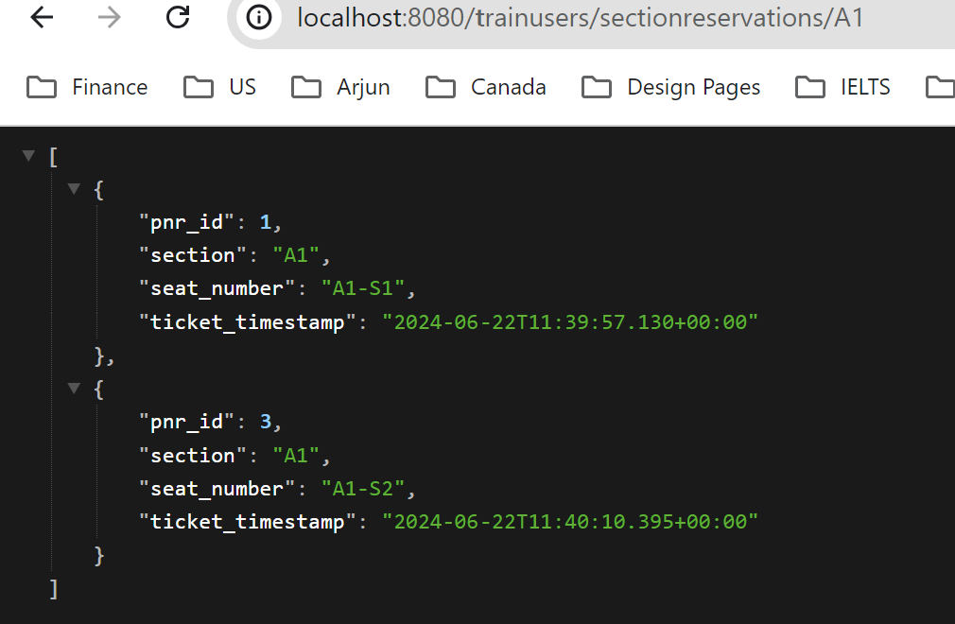



1. [*http://localhost:8080/trainusers/sectionreservations/B1*](http://localhost:8080/trainusers/sectionreservations/B1)

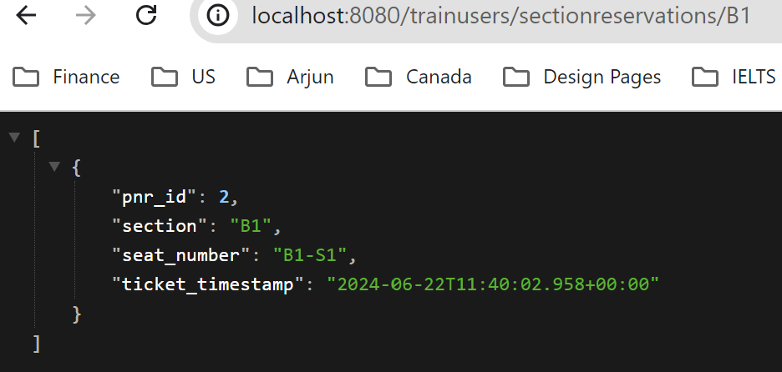



***\*) Ticket Reserved for an user by pnr:***

1. [*http://localhost:8080/trainusers/reservations/1*](http://localhost:8080/trainusers/reservations/1)

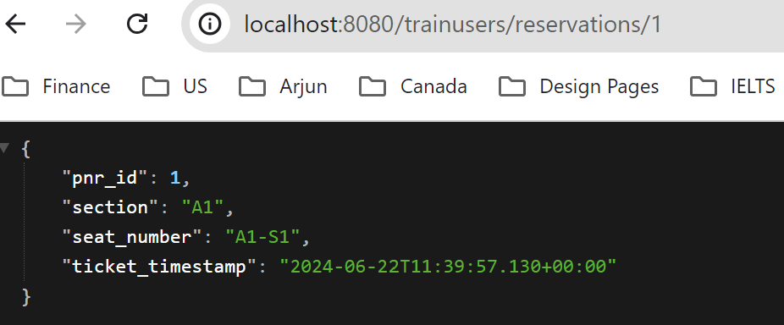

*b. http://localhost:8080/trainusers/reservations/2*

*c. http://localhost:8080/trainusers/reservations/3*

*For all pnr receipts:*

1. [*http://localhost:8080/trainusers/reservations*](http://localhost:8080/trainusers/reservations)

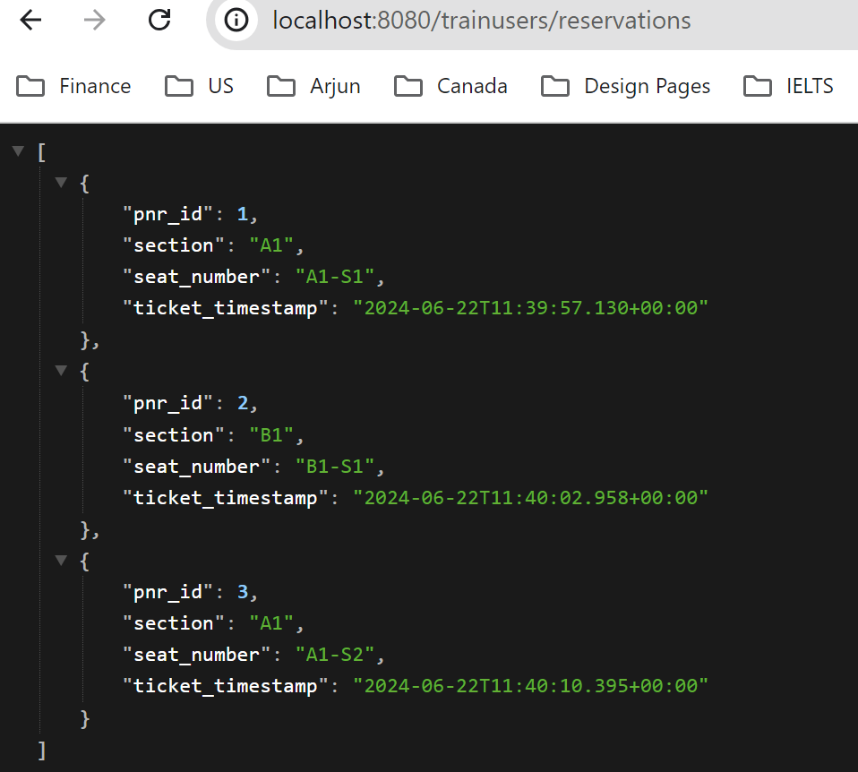

*\*\*\*\*\*\*\*\*\*\*\*\*\*\*\*\*\*\*\*\*\*\*\*\*\*\*\*\*\*\*\*\*\*\*\*\*\*\*\*\*\*\*\*\*\*\*\*\*\*\*\*\*\*\*\*\*\*\*\*\*\*\*\*\*\*\*\*\*\*\*\*\*\*\*\*\*\*\*\*\*\*\*\*\*\*\*\*\*\*\*\*\*\*\**

***4) An API to remove a user from the train:***

*\*) Create gabriella for delete and dont reserve tickets for this:*

*http://localhost:8080/trainusers/3*

*{*

*"user_id": 3,*

*"first_name": "Gabrieala",*

*"last_name": "Sabatini",*

*"email": "Gabrieala@gmail.com"*

*}*

*{*

*"first_name": "Gabrieala",*

*"last_name": "Sabatini",*

*"email": "Gabrieala@gmail.com"*

*}*

*Delete: http://localhost:8080/trainusers/3*

*This will remove gabriella and check in db.*

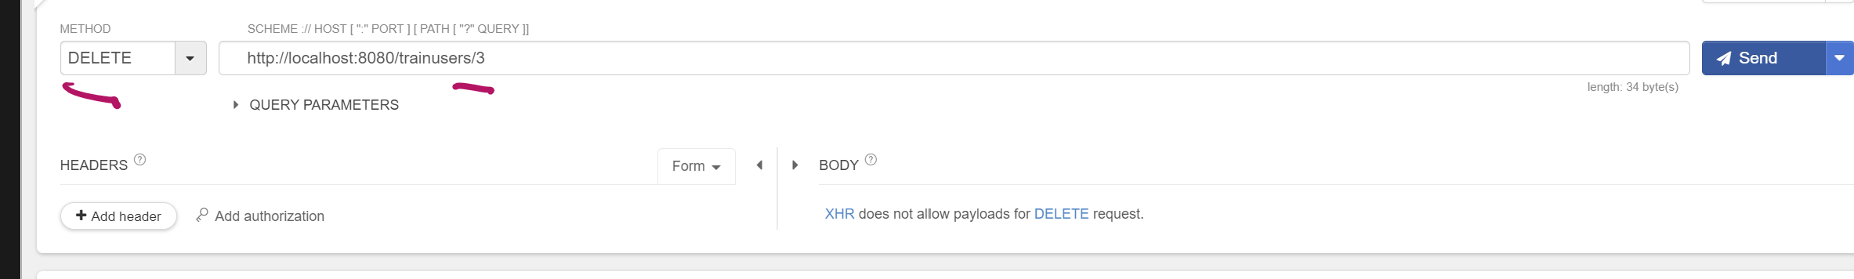

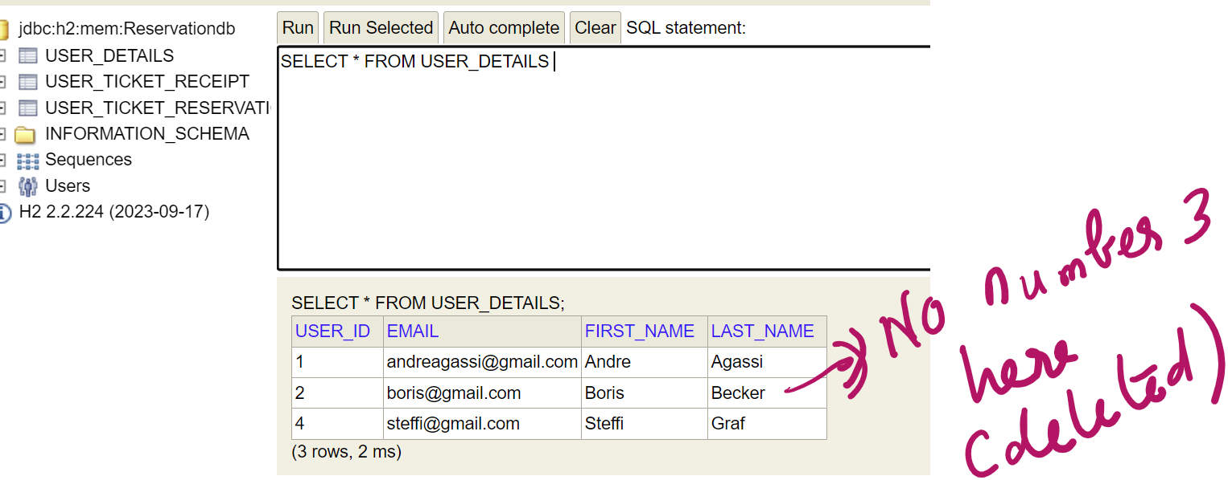

*\*) Try removing the reservation or pnr id:*

1. *Delete:* [*http://localhost:8080/trainusers/reservations/2*](http://localhost:8080/trainusers/reservations/2)

*This will delete the pnr id 2:*

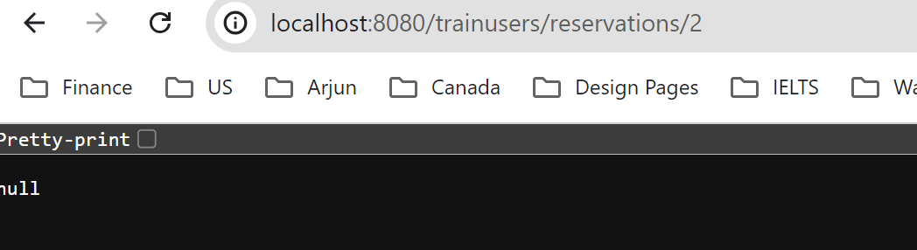

*\*\*\*\*\*\*\*\*\*\*\*\*\*\*\*\*\*\*\*\*\*\*\*\*\*\*\*\*\*\*\*\*\*\*\*\*\*\*\*\*\*\*\*\*\*\*\*\*\*\*\*\*\*\*\*\*\*\*\*\*\*\*\*\*\*\*\*\*\*\*\*\*\*\*\*\*\*\*\*\*\*\*\*\*\**

*5) An API to modify a user's seat:-*

*example make sure that user id 1 linked to pnr id 1 ( user id: 1 and pnr_id 1)*

*http://localhost:8080/trainusers/1/updatereserve*

*{*

*"pnr_id": 1,*

*"section": "B1",*

*"seat_number": "B1-S1"*

*}*

*Here pnr id 1 section and seat number will be changed as per the input given in the request body.*

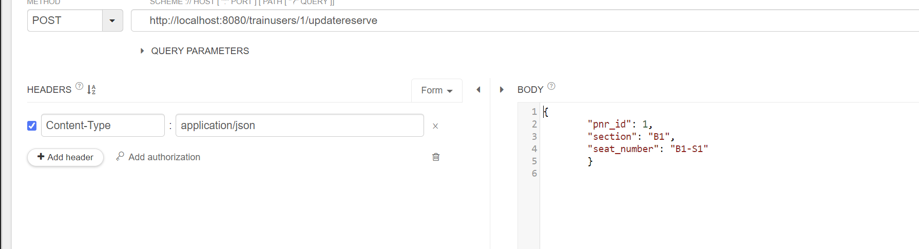

***Previously Pnr Id 1 has tickets reserved in A1-S1***

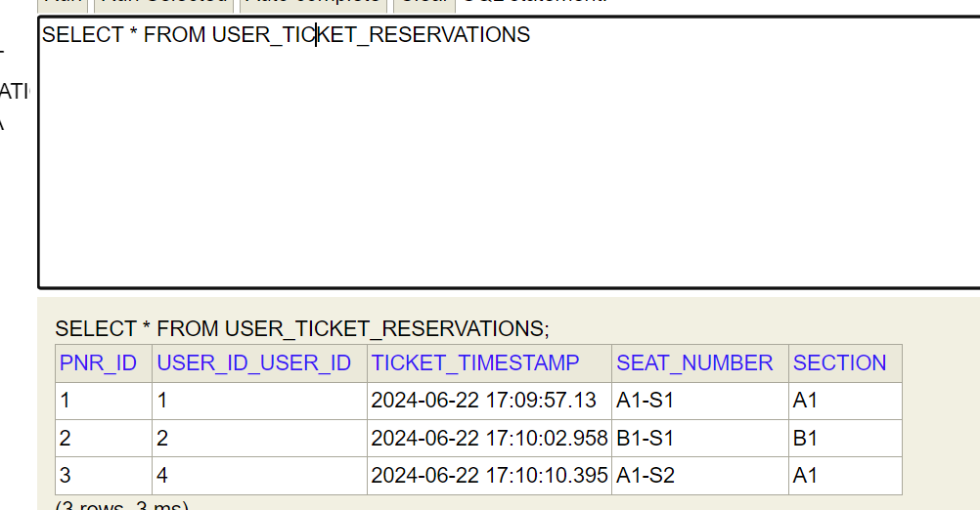



***After the Request processing:***



